
Radford Medical Practice
Psychological Wellbeing Resources

HELP IN A MENTAL HEALTH CRISIS: 0808 196 3779

The crisis line is open 24 hours a day, seven days a week, to all ages and is operated by the Nottinghamshire Healthcare NHS Foundation Trust.
Samaritans
Call us any time, day, or night: Whatever you are going through, you can call us any time, from any phone for FREE. Call: 116 123

Urgent Mental Health Support: Text “SHOUT” to 85258
Get 24-hour text support from a trained volunteer.
It is free, confidential, and anonymous. Whether you are experiencing suicidal thoughts, depression, anxiety, loneliness, or relationship issues.

In- House Social Prescriber
We have a dedicated social prescriber on our team who plays a vital role in supporting your overall well-being. She helps connect you with community resources, social activities, and practical support tailored to your individual needs. Whether you are feeling isolated, need advice on managing finances or struggling with buying food, she’s here to listen and guide you towards the right services and opportunities to help you.

In- House Mental Health Nurse
Our GPs will be able to refer you to an appointment with our mental health nurse. Whether you need guidance on coping strategies, medication support, or someone to talk to during difficult times, she is here to ensure you get the right care and support to improve your mental health.

Nottingham Talking Therapies

Tel: 0333 188 1060
To self-refer visit: www.notts-talk.co.uk/getting-support/.
This service offers free and confidential support for individuals dealing with common mental health problems such as stress, anxiety, and low mood.
-
Nottingham Counselling Centre
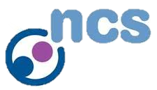
An independent service, delivering high-quality, inclusive, and diverse counselling services for individuals, couples, and families seeking support.
To self-refer visit: www.nottinghamcounsellingcentre.org.uk or call 0115 9501743.

Student Space (from Student Minds)

Student Space offers expert information and advice to help you through the challenges of student life, including struggles with your mental health, studies, money, or relationships. Student Space can get you in touch with trained volunteers, via text message, webchat, or email. Visit www.studentspace.org.uk to find out more.


Student Minds
Student minds is a UK charity seeking to improve university communities by empowering students to build on their own mental health and support themselves and their peers through university life and beyond. Their site offers resources uniquely designed to 1 some of the major challenges faced by students, as well as their friends and family. Visit www.studentminds.org.uk to see what support is available to you.


Muted
Muted is a Nottingham based charity helping create awareness and help to men with depression. Everything from the first contact is confidential and judgement-free. They offer phone and online sessions, as well as holding regular events to generate awareness of the importance of mental health. Visit their website, www.muted.org.uk and fill in the contact form to get in touch.

Silver Cloud

Silver cloud is an online system, operated by NTU, designed to help with a range of mental health issues. The content is motivational, easy to use, interactive and relevant to students. It can be especially helpful if you are experiencing anxiety, depression, stress or eating issues.
By completing their Wellbeing Quiz, and selecting a programme, you can access the modules and exercises designed to apply to your daily life. Visit: ntu.silvercloudhealth.com/signup/natur/Students/

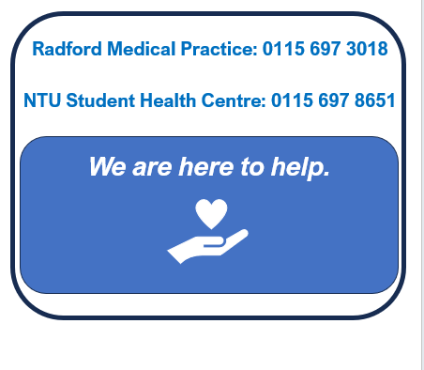

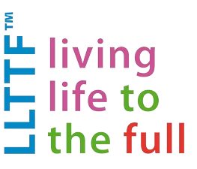
Living Life to the Full
LLTTF offers a wide range of courses, based on the principles of Cognitive Behavioural Therapies (CBT), to help empower and equip people to cope with negative thoughts or feelings. There are several free resources available through LLTTF, though some courses are subject to a fee. Visit www.llttf.com for more information.


Papyrus
Papyrus Prevention of Young Suicide is a UK charity dedicated to the prevention of suicide and promotion of positive mental health and emotional wellbeing in young people. They operate a free and confidential helpline, which is available 24 hours a day, 7 days a week. If you are having thoughts of suicide or are concerned for a young person who might be you can contact HOPELINE247 for confidential support and practical advice. Call: 0800 068 4141, Text: 88247 or Email: pat@papyrus-uk.org

Nottinghamshire Sexual Violence Support Services

Available to survivors of all genders, the Notts SVS Services offer support to those who have experienced sexual violence or abuse. This includes face-to-face counselling, helpline services, and services for women in a women-only space. Visit www.nottssvss.org.uk/contact/ to self-refer.


Kooth
Kooth is an award-winning service that provides free online counselling, support and advice to Nottingham City residents aged 10-24. They offer an online live chat service where you can chat with BACP accredited counsellors and emotional wellbeing practitioners (see website for messaging hours). You send a message to the team, and they will get back to you. Visit www.kooth.com for more information.

Alcoholics Anonymous

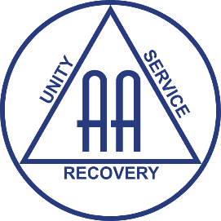
AA supports individuals struggling with alcoholism to achieve and maintain sobriety. AA is freely available to all, the only requirement for membership of AA is a desire to stop drinking. For more information about the free weekly meetings, and additional support services visit www.alcoholics-anonymous.org.uk or call the local helpline on 0115 941 7100 (365 days a year, 8:00-00:00) or email help@alcoholics-anonymous.org.uk
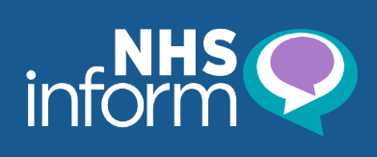
NHS Inform
NHS Inform offers free information and resources on a variety of mental health problems and disorders. You can also access a number of self-help guides for conditions such as Anxiety, Depression, Insomnia and many more. Visit www.nhsinform.scot/illnesses-and-conditions/mental-health/.

Thriving Nottingham: Thriving Nottingham is a free, city-funded health and wellbeing service for Nottingham residents (who live or are registered with a GP in the city).They offer help with Health coacing, help to stop smoking, Losing weight, free excerise classes. Call: 0115 648 5724 or Visit: https://thrivingnottingham.org.uk/
, s
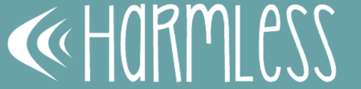
Harmless: Harmless is an organisation who works to address and overcome issues related to self-harm and suicide. They offer a variety of support including 1-1 sessions, Keeping In Touch (KiT) clinics, evening mental health crisis drop-ins and text message support. You will be given a document that outlines what is available within your area. If you are seeking support for yourself or a loved one, visit www.harmless.org.uk/support-available/
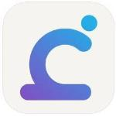
Calm Harm :Calm Harm is an app designed to help you manage or resist the urge to self-harm. The app is private, anonymous, and safe, and uses principles from an evidence-based psychological treatment called Dialectical Behaviour Therapy (DBT). Calm Harm is availible via the App Store or Google Play.

FREED: FREED is First Episode Rapid Early Intervention for Eating Disorders. It is a service for 16 to 25-year-olds who have had an eating disorder for three years or less. Their website provides access to resources designed to support inidviduals suffering with EDs. Visit their website to view their guides and to contact them for support: https://freedfromed.co.uk/freed-for-all

GamCareIf you are concerned about the amount of time or money that you or someone you know is spending gambling, you can talk in confidence to advisers free of charge over the phone or online. They are available 24 hours a day, seven days a week, call them on 0808 8020 133. You can also chat with an advisor via live chat www.gamcare.org.uk/get-support/talk-to-us-now/
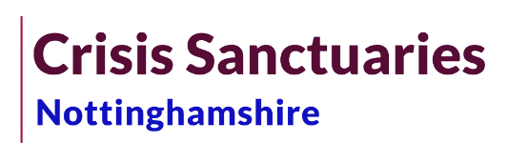
Nottingham Crisis Sanctuaries:The Crisis Sancturies are for adults (18+) who are presently in, or nearing, a mental health crisis. Contact them on 0330 822 4100; phone lines are open from 4pm till 11pm every day, seven nights a week.There are 3 crisis sanctuary locations (Nottingham City, Chilwell, and Mansfield).
.

Visit www.nottinghamshirecrisissanctuaries.tv/visit to find addresses and opening hours.

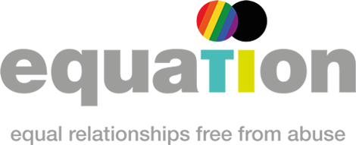
Equation : Equation is a Nottingham-based specialist charity that seeks to reduce the impact of domestic abuse, sexual violence and gender inequality. They offer inclusive support, tailored to men, women and LGBTQ+ individuals. Equation have separate helplines depending on the individual, please visit their website for the full list of telephone numbers. Email: helpline@equation.org.uk (Mon – Fri 9.30am – 4.30pm) or visit www. equation.org.uk for self-referals and more information.
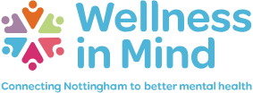
Wellness in Mind: Wellness in Mind provides information, advice, and support for anyone in Nottingham experiencing issues with their mental wellbeing. The service will help people understand mental health issues and connect people to the services which may best support them. This includes Primary and Secondary mental health services. For more information, visit: www.wellnessinmind.org

Nottingham Recovery Network: The Nottingham Recovery Network provide drug and alcohol support for people living in Nottingham City. They offer a wide range of services from triage to ongoing recovery support and rehabilitation in the community. They can also help with substance use, physical and mental health issues and homelessness and housing issues as well as support for getting back into work. The NRN also offer drop-in assessments in the city centre. To find out more call 0800 066 5362 or get in touch online via www.nottinghamrecoverynetwork.com

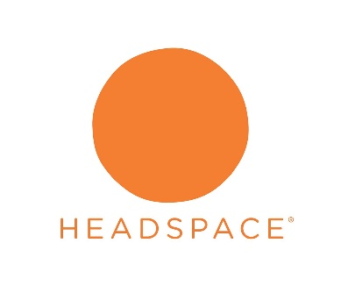
Headspace: Headspace is an app that aims to help you create life-changing habits to support your mental health, through evidence-based meditation and mindfulness tools. Headspace is availible via the App Store or Google Play. The service is £9.99/month or £49.99/year.

The Topaz Centre

Topaz offers free, confidential healthcare and compassionate support, in Nottinghamshire, to adults (18+) that have experienced sexual assault or rape in their lifetime. Topaz can provide you with medical assessments/treatment, forensic examinations, aftercare referrals as well as support and guidance.
Their phone line (0330 223 0099) is open 24 hours a day, every day of the year.
Call to speak with a nurse for support and to discuss your options for making an in-person appointment and/or referral.
You can also email at notts.sarc@nhs.net (monitored 9am-5pm, Monday-Friday).

Gendered Intelligence: Gendered Intelligence offers a range of services that aim to support Transgender / Non-binary individuals and their families.

They operate a free and confidential support line service for individuals (18+) to answer any questions that you might have and to provide you with support while you wait for gender affirmative healthcare. Everyone who answers is trans and/or non-binary themselves.
Phone number: 0800 640 8046.
Email: supportline@genderedintelligence.co.uk
WhatsApp: 07592 650 496
(Available Mon: 12-5pm Tue: 2-7pm Wed: 10-3pm Thurs: 12-5pm Fri: 10-3pm)


MoodMission: MoodMission is an evidence-based app designed to empower you to overcome feelings of depression and anxiety by discovering new and better ways of coping. MoodMissions is availible via the App Store or Google Play and using it will give you a tailored list of 5 simple, quick and effective, “Missions” to improve your mood. To learn more, visit www.moodmission.com.


Calm:Calm is an app that offers a variety of tools, designed to help you stress less, sleep more and live mindfully. On the app, users can access a number of stress relief programs, guided meditations, sleep sounds, and other features designed to fit into your lifestyle in practical ways. The subscritpion fee is £39.99/yr and it is availible via the App Store or Google Play Store.

